**Program 6**

**PART-A**

**A.1 Aim:**

**Write Jquery codes to perform the following events and actions**

1. Animate a div element to change its height, width, position and background color
2. Animate a paragraph to fade to an specified opacity (complete the animation within 500 milliseconds).
3. Animates all divs to slide down and slide up.
4. Use jQuery to modify the transition speed of the buttons’ color
5. Create an image slider with jQuery.

**A.2 Prerequisite:**

HTML, CSS, Java (only for programming basics)

**A.3 Outcome:**

After successful completion of this experiment students will be able to

1. Understand and implement jQuery selectors, events and actions

**A.4 Theory:**

* jQuery is one of many available libraries that provide functions for manipulating the web page with fairly good performance
* Helps to keep your JS code clean
* jQuery has selectors, events and actions.
* Selectors are the same as in CSS – tag, class, id, sibling, descendant
* Events are click, dblclick,

|  |  |  |
| --- | --- | --- |
| keypress | submit | load |
| keydown | change | resize |
| keyup | focus | scroll |
|  | blur | unload |

* jQuery has animations like hide, show, toggle, fadeIn,fadeout,slideUp,slideDown
* Example codes as given below

<script src="jquery-1.8.2.min.js"></script>

<span id="stuff"></span>

<form><input id="inpt" onchange="doit()"></form>

<script>

function doit() {

$("#stuff").text($("#inpt").val());

}

</script>

* $("button").click(function(){  
    $("p").hide("slow", function(){  
      alert("The paragraph is now hidden");  
    });  
  });

**PART B**

|  |  |
| --- | --- |
| **Roll No. : E009** | **Name: Dhrumil Burad** |
| **Class : B.tech CSBS** | **Batch : B1** |
| **Date of Experiment: 18-02-2023** | **Date of Submission : 20-02-2023** |
| **Grade :** |  |

**(PART B: TO BE COMPLETED BY STUDENTS)**

**(Students must submit the soft copy as per following segments within two hours of the**

**practical. The soft copy must be uploaded on the Blackboard or emailed to the concerned lab in charge faculties at the end of the practical in case the there is no Black board access available)**

**B.1 Software Code written by student:**

**(Students must paste the code here)**

<!DOCTYPE html>

<html lang="en">

<head>

    <meta charset="UTF-8">

    <meta http-equiv="X-UA-Compatible" content="IE=edge">

    <meta name="viewport" content="width=device-width, initial-scale=1.0">

    <title>Practical 6</title>

    <script <script src="https://ajax.googleapis.com/ajax/libs/jquery/3.6.3/jquery.min.js"></script>

    <style>

        img {

            width: 150px;

            height: 150px;

        }

    </style>

</head>

<body>

    <p> 1. Animate a div element to change its height, width, position and background color</p>

    <div style="border: 3px solid black;" id="t1d">This is div for Q1</div>

    <button id="b1">Change Div</button><br>

    <p>2. Animate a paragraph to fade to an specified opacity (complete the animation within 500 milliseconds).</p>

    <p id="t2p" style="font-size: 20px; background-color: rgb(8, 0, 255);">THIS IS A PARAGRAPH FOR Q2</p>

    <button id="b2">Change para</button><br>

    <p>3. Animates all divs to slide down and slide up.</p>

    <div id="t3d" style="font-size: 20px; background-color: rgb(255, 0, 225); height: 30px;">THIS IS A DIV FOR Q3 </div>

    <br>

    <button id="b3">Slide Divs</button>

    <br>

    <p>4. Use jQuery to modify the transition speed of the buttons’ color<br></p>

    <button id="b4" style="height: 35px;">

        <div id="t4d">Click to change the colour</div>

    </button>

    <br>

    <p>5. Create an image slider with jQuery.<br>

        <img id="img1" src="./dog.jpg">

        <img id="img2" style="display: none;" src="./fox.jpeg">

        <img id="img3" style="display: none;" src="./download.jpeg">

        <br>

        <br>

        <button id="b5">Previous </button>

        <button id="b6"> Next</button>

    </p>

    <br>

    <br>

    <br>

    <br>

    <script>

        $(document).ready(function () {

*//Q1*

            $("#b1").click(function () {

                $("#t1d").animate({ height: "50px", width: "300px", margin: "100px" }, 1000).css("background-color", "red");

            });

*//Q2*

            $("#b2").click(function () {

                $("#t2p").animate({ opacity: 0.25 }, 500)

            })

*//Q3*

            $("#b3").click(function () {

                $("#t3d").slideUp(3000).slideDown(3000)

            })

*//Q4*

            $("#b4").click(function () {

                $("#b4").css({

                    "transition": "background-color 5s", "background-color": "red"

                })

            })

            let i = 1;

            let j = 0;

            let k = 0;

            $("#b6").click(function () {

                if (i == 1) {

                    i--;

                    console.log("i 1st", i);

                    console.log("j 1st", j);

                    console.log("k 1st", k);

                    $("#img2").fadeIn(0)

                    $("#img1").hide()

                    j++;

                    console.log("j 1st2", j);

                }

                else if (j == 1) {

                    console.log("i 2nd", i);

                    console.log("j 2nd", j);

                    console.log("k 2nd", k);

                    j--;

                    $("#img3").fadeIn(0)

                    $("#img2").hide()

                    $("#img1").hide()

                    k++;

                    console.log("j in 2nd1", j);

                    console.log("k in 2nd1", k);

                }

            })

            $("#b5").click(function () {

                if (k == 1) {

                    k--;

                    console.log("i 3rd", i);

                    console.log("j 3rd", j);

                    console.log("k 3rd", k);

                    $("#img2").fadeIn(0)

                    $("#img3").hide()

                    j++;

                    console.log("j", j);

                }

                else if (j == 1) {

                    j--;

                    $("#img1").fadeIn(0)

                    $("#img2").hide()

                    $("#img3").hide()

                    i++;

                }

            })

        })

    </script>

</body>

</html>

**B.2 Input and Output**

**(Students must paste input and output here)**

# **Q1:**



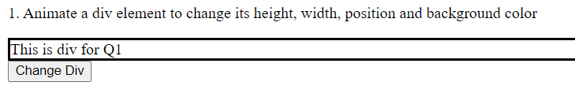

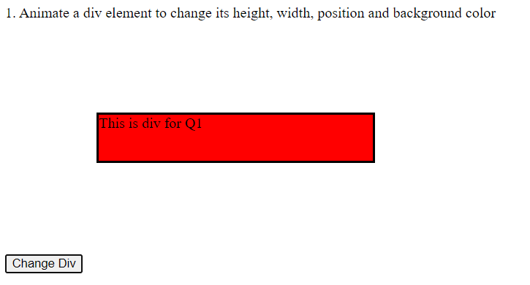

# Q2



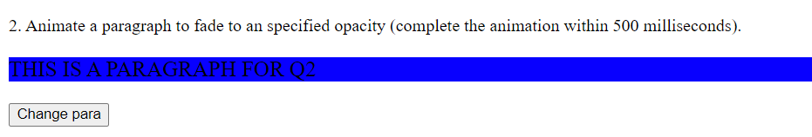

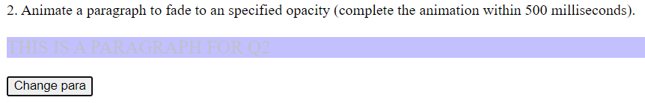

# Q3

# 

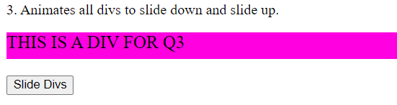

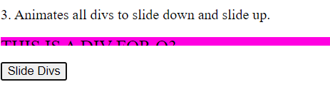

# Q4

# 

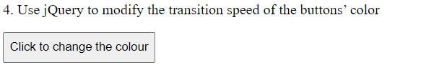 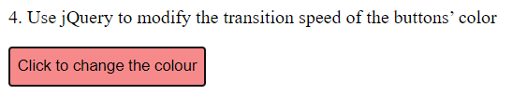

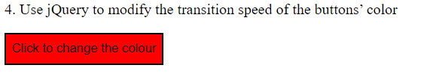

# Q5



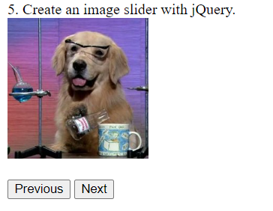

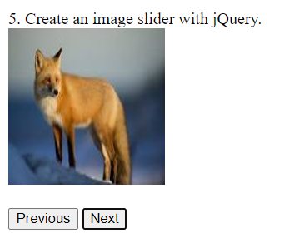

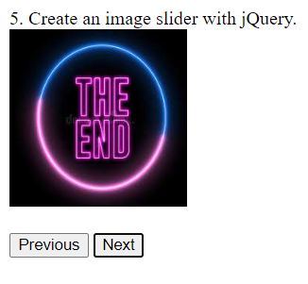

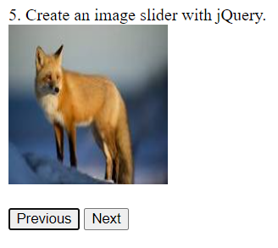

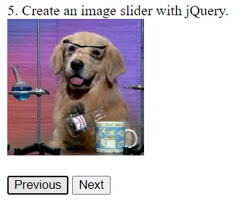

**B.3. Observations and Learning**

**(Students are expected to comment on the output obtained with clear observations and learning for each task/ sub part assigned**

Learnt and understood about jQuery and how to write commands to perform various tasks using jQuery. Implemented jQuery selectors, events and actions. Also got to know how jQuery reduces the commands required to perform the same action than in JavaScript

**B.4. Conclusion**

**(Students must write the conclusion as per the attainment of individual outcome listed above and learning/observation noted in Sec. B.3)**

Successfully performed the given tasks using jQuery